

BROAD RIPPLE HAVERFORD LITTLE LEAGUE

2022 SAFETY PLAN

Prepared by:
Cason Cusak, BRHLL Safety Officer
Thomas Mariani, BRHLL President
Safety is Everyone's Responsibility

Broad Ripple Haverford Little League's (“BRHLL”) highest priority is for the safety of our children. Prevention is the key to reducing accidents.

At BRHLL we are committed to encouraging and providing a safe environment. In order to succeed we need your commitment to adhere to the guidelines contained in this safety manual. BRHLL is actively participating in Little League's A Safety Awareness Program (“ASAP”), whose mission is "to increase awareness of the opportunities to provide a safer environment for children, volunteers and all Little League participants.”

The purpose of this manual is to provide important safety information to BRHLL. While specifically written for Managers and Coaches the information contained in this document can be a useful resource for all participants of BRHLL. Please take the time to review this manual in its entirety.

We request your assistance and guidance in continuing to make BRHLL a great program. If you have any concerns, or suggestions for improvement, please contact us at president@brhll.com or safety@brhll.com. For additional information please visit our web site www.brhll.com.

We want to hear from you!

Thank you for your commitment to manage and coach in BRHLL.

The BRHLL Board of Directors
Introduction to the BRHLL Safety Plan

The Safety Plan herein refers to play at the Main Fields (Diamonds 1, 2 and 3) located behind IPS School 55, 1300 E. 54th Street, Indianapolis, Indiana 46220; Fairgrounds Fields (Diamonds 4, 5 and 6) located on south of 46th street (closest intersection is 46th and Crestview) on the north side of the Indiana State Fairgrounds; Indiana School for the Deaf (Diamonds 7 and 8) located behind the Indiana School for the Deaf, 1200 E. 42nd Street, Indianapolis, Indiana 46205; Broad Ripple High School (Diamond 9) located at 1115 Broad Ripple Ave, Indianapolis, Indiana 46220; and Bishop Chatard High School (Diamonds 10 and 11) located at 5885 N. Crittenden Ave, Indianapolis, Indiana 46220, as well as any off-site practices or games.

Further information beyond this document regarding safety and the ASAP program is available by contacting the BRHLL League Safety Officer listed below.

There are several points addressed in this document that are required for an approved ASAP compliant Safety Plan. The following is a list of the important features, policies, and requirements of the Safety Plan:

- Active Safety Officer
Broad Ripple Haverford Little League (BRHLL) has an active safety officer who is also a member of the Board of Directors. For the 2022 Season, the safety officer is:

Cason Cusak
((317)667-4678 (cell)
Email: safety@brhll.com

- Distribute a Safety Manual
The Broad Ripple Haverford Little League Safety Manual is available online at www.brhll.com and all Managers and Coaches should download a copy to your smart phone, tablet, or computer. A copy of BRHLL’s Coronavirus Mitigation Protocol is attached as an appendix.

- Post board and emergency numbers
All managers and coaches shall use “911” for all on field emergencies requiring fire, police, or ambulance. Managers and coaches shall keep player emergency contact information with them at all times and have a working cell phone during practice and games.

The emergency contact information sheet is contained in the appendix, which also contains contact information for league officers and coordinators and will be posted in the concession stands. Also, Emergency Contact Procedures to assist in the event of an emergency situation are provided with the contact information.

If a manager, coach, player, or umpire tests positive for COVID-19, they should notify BRHLL Safety Officer, Cason Cusak at (317)667-4678 and BRHLL President, Thomas Mariani at (317) 607-5904 of that positive test.

- Background Checks for Volunteers

BRHLL Child Protection Program

BRHLL utilizes the Little League® Volunteer Application – 2021, JDP Background Screening, and checks for sex abuse history as well as criminal background. BRHLL requires all managers, coaches, board members, and any other persons, volunteers or hired workers, who provide regular services to the league or who have repetitive access to or contact with the players or teams, to complete and application form and the JDP Background Screening as well as provide a government issued photo identification card for ID verification. BRHLL conducts a search of the appropriate governmental entity of the nationwide sex offender registry on all volunteer applications received through resources such as First Advantage. Anyone refusing to fill out a volunteer application will not be considered for a volunteer position or even be a league member. The league president is required to retain these confidential forms for one year of service. After such year of service, these forms will be destroyed.

Little League® Volunteer Application – 2021

Child Abuse Prevention and Requirements to Report Child Abuse in Indiana

Indiana Child Abuse and Neglect Hotline

1-800-800-5556
If you suspect a child is being abused or neglected, call Indiana's Child Abuse and Neglect Hotline today. It is available 24 hours a day, 7 days a week, 365 days a year. You do not have to be afraid anyone will find out who made the report because you can report abuse and neglect anonymously.
Who is required to report child abuse or neglect?
Under Indiana law any individual who has a reason to believe a child is a victim of abuse or neglect has the duty to make a report; therefore, each citizen of Indiana is considered a “mandated reporter.” While reporting child abuse is everyone’s responsibility, Indiana law requires some in certain occupations to do so. These professional reporters are staff members in a medical or other public or private institution, school, facility, or agency. These reporters are legally obligated by their profession to report alleged child abuse or neglect.
Everyone has an important role and responsibility to prevent child abuse and neglect. Children need everyone to stand up for their safety when they may be in harm's way or when families in crisis or turmoil need support from those close to them. By contacting the Indiana Child Abuse and Neglect Hotline if you suspect a child is a victim of abuse or neglect, you can play your part in protecting a child and/or making it possible for a family in crisis to get the help and support they need.
For more information: http://www.in.gov/dcs/2971.htm

- Provide Fundamentals Training
Broad Ripple Haverford Little League conducts annual softball and baseball coaches’ clinic prior to each season. The 2022 Coaches’ Clinic will be held March 5, 2022.

This event is REQUIRED for ALL baseball and softball managers AND at least ONE coach for each team. We will be taking attendance. Involving our coaches is vital to the future of our league – they are the future managers! If you have a scheduling conflict, please contact Chad Saalfrank, Director of Coaching/Player Development.

- Require First Aid Training
Basic first aid training is overviewed in the BRHLL annual coaches’ meeting prior to the season starting and again at a special First Aid training on an online conference platform (e.g., Zoom, Microsoft, Skype). Coaches will receive first aid kits with their equipment bags and replacement ice packs are available in the equipment room above the 54th Street concession stand.

BRHLL has acquired two automatic external defibrillators (“AED”), which will be located at the concession stands at both the Main Fields (Diamonds 1, 2 and 3) and the Fairgrounds Fields (Diamonds 4, 5 and 6). The members of the Board of Directors, who also serve as the Officers of the Day on game days, will be receiving AED training on the use of these devices and the general operation of the AEDs will be demonstrated at the First Aid training prior to opening day.

- Field Inspections
The BRHLL fields and surrounding areas are reviewed on a regular basis during the season by the Safety Officer and/or other Board Members. In addition, BRHLL team managers, coaches and umpires will be required to review the field on which they will be playing before each game to look for and correct any unsafe conditions (holes, broken glass, rocks, equipment, etc.) prior to the start of play.

Please refer to checklist in the appendix section of this document. Any field or areas used for league practices shall be inspected for unsafe conditions by team coaches prior to all league practices as well.

- 2022Annual Little League Facility Survey
BRHLL conducts a formal Facility Survey that is updated on an annual basis and submitted to the Little League Headquarters in Williamsport, PA, along with this Safety Plan. A copy of the Facility Survey is located in the appendix section of this document.

- Concession Stand Procedures
BRHLL has a contract to outsource the operation and management of the concession stand adjacent to the Main Fields (between Diamonds 1 and 2), and to operate an additional concession stand at the Fairgrounds Fields (between Diamonds 4, 5 and 6). A grill and deep fryer are used for preparation of hot dogs, hamburgers, French fries and chicken.

The concession stand vendor operates the concession stands in accordance with the rules and regulations of the Marion County, Indiana Board of Health and is responsible for training all of its workers in the safe handling, cooking and storage of food, proper hand washing, and the cleaning of all utensils, cooking surfaces and food handling equipment. A copy of the Concession Stand Policy is in the appendix section of this document. The Safety Officer will meet with the concession stand vendor before Opening Day to discuss BRHLL Coronavirus Mitigation Protocol.

10. Regular Inspection of Equipment
Regular inspection of equipment is necessary to ensure safety. Replacement of defective equipment must be done immediately by contacting the Equipment Manager or any league official. Equipment checks are done formally by three sources:

  - By the equipment manager at the beginning of the season and periodically throughout the year;
  - By coaches at the beginning of each game; and
  - Umpires during the course of games.
11. Accident Reporting and Tracking:
An incident that causes any player, manager, coach, umpire, or volunteer to receive medical treatment and/or first aid must be reported to the league Safety Officer at safety@brhll.com no later than 24 hours after it occurs.

BRHLL will provide hardcopy printouts of the Incident / Injury Tracking Report (included in the appendix) with all First Aid kits that are provided to every Team as part of the standard issue equipment. This will allow teams to have the form with them when at practices or games. In addition, copies of this form will be kept in the concession stands at both the Main Fields and the Fairgrounds Fields.

A coach or league official must complete the incident/injury tracking report. The coach or official should email the report to the Safety Officer at safety@brhll.com. If you have an iPhone, iPad or similar device, you can email a clear picture of the completed form.

This includes even passive treatments such as the evaluation and diagnosis of the extent of the injury or periods of rest.

For any injury, accident or illness requiring a 911 call or likely visit to the doctor or emergency room, please call BRHLL Safety Officer, Cason Cusak at (904) 860-7700 as soon as possible after the incident. If you cannot reach the safety officer, then contact BRHLL President, Thomas Mariani at (317) 607-5904 so that appropriate follow-up and support can be made in a timely manner.

Follow-Up by Safety Officer:

Within 2 days following the report of an incident, the Safety Officer will contact the injured party or the party’s parents and:

- Verify the information received;
- Obtain any other information deemed necessary;
- Check on the status of the injured party; and
- In the event that the injured party required other medical treatment (i.e., Emergency Room visit, doctor’s visit, etc.), advise the parent or guardian of BRHLL’s insurance coverages and the provisions for submitting any claims.

If the extent of the injuries is more than minor in nature, the Safety Officer shall periodically call the injured party to:

- Check on the status of any injuries, and
- Determine if any other assistance is necessary in areas such as submission of insurance forms, etc.

The Safety Officer will continue this process until such time as the incident is considered “closed” (i.e., no further claims are expected and/or the individual is participating in the league again). An Accident Notification Form will be generated and sent to Little League Headquarters in Williamsport and reported to the District Safety Officer when required.

All incidents and accidents should be reported to the Safety Officer within 24 hours of the incident so that timely follow-up and tracking can occur.

A Brief Explanation of the Little League Insurance Program
The Little League Insurance program is designed to afford protection to all eligible participants at the most economical cost to BRHLL. Little League Insurance covers all eligible participants while traveling directly, without delay, to and from the field as well as during practice sessions and games. The benefits include provisions for accident, death, or dismemberment and also for medical expense.

This insurance is only meant to supplement other insurance carried under a family policy or provided by the injured person’s private insurance. If there is no other coverage, Little League Insurance which is purchased by Broad Ripple Haverford Little League, not the parent, takes over and provides benefits for all covered injury treatment costs, up to the maximum stated benefits.

This plan makes it possible for BRHLL to offer low cost protection that most youth sports cannot match, with assurance to parents that adequate coverage is in force at all times during season.

If your child sustains a covered injury while taking part in Little League Baseball or Softball, here is how the insurance works:

- Any injury must be reported within 24 hours to the BRHLL Safety Officer, Cason Cusak at safety@brhll.com or (904) 860-7700, and the BRHLL President, Thomas Mariani at president@brhll.com or (317) 607-5904.

- File a claim under the insurance carried by the family.

- Should your family insurance plan not fully cover the injury, the Little League Insurance Policy will help pay the difference up to the maximum stated benefits. This includes any deductibles or exclusions in your own policy.

- If your child is not covered by any family insurance, the Little League Insurance Policy becomes primary and will provide benefits for all covered injury treatment costs up to the maximum benefits of the policy.

- Treatment of dental injuries can extend beyond the normal 52 week period if dental work must be delayed due to physiological changes of a growing child. Benefits will be paid at time treatment is given, even though it may be some years later. Maximum dollar benefit is $500.00 for eligible deferred dental treatment after the normal 52 week period.

- First Aid Kits:
A First-Aid Kit is required to be on hand for every game and practice. BRHLL supplies each team a First-Aid Kit with the team’s equipment bag. In addition, First-Aid Kits and first aid supplies are located in the concession stand and, in the equipment, shed for use as needed. If supplies are depleted during the season, contact the Safety Officer or a league official for replacements.

13. Little League Rules
BRHLL Managers, Coaches, Umpires, and League Officials are required to enforce Little League rules at all games and practices, including proper equipment. Most Little League rules have some basis in safety, so it is important to follow them. A list of both BRHLL league rules and key Little League rules pertaining to safety is below.

FIELD AND DUGOUT SAFETY
It is important to remember that we want to make baseball a safe and enjoyable experience for all the players. A bulleted list of several of the league policies and key Little League baseball rules regarding field and dugout safety follows.

- A first-aid kit and first aid supplies are located in the concession stand at the Main Diamonds and in the concession stand at the Fairgrounds Fields. In addition, each team is issued a first-aid kit with the team’s equipment bag. If supplies are depleted during the season, contact the Safety Officer or league officials for replacements.

- No games or practices should be held under severe weather conditions (especially lightning) or when field conditions are unsafe. It is important for coaches and officials to be diligent with regard to playing conditions. Always err on the side of caution.

- Follow league policy regarding Lightning Safety.

- The fields and surrounding areas must be inspected on a regular basis. The field will be reviewed before each game by the umpire and team coaches to look for and to correct any unsafe conditions (holes, broken glass, rocks). Any field or areas used for league practices shall be inspected for unsafe conditions by team coaches prior to all league practices.

- A Little League Facility Survey is updated annually, submitted to Little League headquarters and kept on file. Contact the Safety Officer or a league official for a copy or access if necessary.

- Only players, managers, coaches and umpires are permitted on the playing field during play and practice sessions.

- All bats and loose equipment must be kept off the playing fields. Bat racks should be placed behind screens. Organized equipment can prevent tripping hazards.

- Coaches should establish a procedure for retrieval of foul balls batted out of play. During practice sessions and games, all players should be alert and watching the batter on each pitch.

- Coaching staffs, Safety Officer and umpires are responsible for the regular inspection of equipment. This includes both league equipment and equipment brought by the player. Non-safe equipment must be removed immediately and replaced as soon as needed. Make sure the equipment is properly fitted to the players.

- Ensure players have required equipment at all times, even catchers warming up pitchers.

- All fields are to use bases that disengage from their anchors, as required by Little League.

- Pitching Machines will be maintained in good working order and must be operated only by adult Managers and Coaches.

- “Horseplay” should not be permitted on the playing fields.

PLAYER SAFETY
BRHLL and Little League key rules pertaining to player safety are outlined below:

- Coaches should inspect equipment on a regular basis, making sure it fits correctly and is in proper working order. Broken or improper equipment can be replaced by contacting the Equipment Manager or league officials. Batting and catching helmets are not permitted when they have been painted by anyone other than the manufacturer.

- Batters must wear protective helmets during practices and games.

- Catchers must wear a catcher’s helmet with face mask and throat guard, chest protector and shin guards. Male catchers must also wear a cup at all times.

- Warm-up catchers must wear catcher’s helmet, facemask, and throat guard while warming up pitchers (skull caps are not permitted). This applies between innings, during bull-pen warm-ups and pre-game infield drills. Adults may NOT warm up a pitcher (Rule 3.09). This is a safety issue for both the player and the adult.

- Rule 7.08a (sections 3, and 4) is particularly important for safety. A runner must slide OR avoid a fielder who has the ball and is waiting to make the tag. Except when returning to base, no head-first slides are permitted. If any coach or parent is unsure of the proper interpretation of Rule 7.08a please see the Safety Officer or other league officials.

- Coaches shall instruct all players in safe sliding techniques as well has how to avoid a pitched ball.

- Players must not wear watches, rings, pins, jewelry or other metallic items by Little League baseball rule.

- Parents of players that wear glasses should be encouraged to provide “safety glasses”.

- No on-deck batters are allowed. No player should handle a bat even while in an enclosure, until it is his/her turn at bat at games or at practice.

- Players who are ejected, ill or injured should remain under coach supervision until released to the parent or guardian.

- After a game or practice, coaches should not leave the area until all players have been picked up.

- Players will be instructed in proper stretching and general sports health maintenance procedures, including proper throwing, fielding and hitting techniques to limit injury.

- Injuries should be reported immediately per BRHLL’s “Accident Reporting & Tracking” procedures as outlined in the Safety Plan.

- Pitcher’s helper in Minors baseball and softball will wear face mask.

14. League Registration Data Reporting
BRHLL will submit via the Little League Data Center player, coach and manager data by the required date.
APPENDIX

- Emergency BRHLL Contact Information

- Emergency Contact Procedures

- Hey Coach! Game Day Flyer

- Lighting Safety Policy and Brochure

- Concession Stand Policy

- Communicable Disease Procedures

- Youth Sports Parent Code of Conduct

- BRHLL Volunteer Code of Conduct

- CDC Heads Up Concussion in Youth Sports Fact Sheet for Coaches

- Injury Tracking Form

- Accident Notification Form

- 2022 BRHLL Facility Survey

- 2022 BRHLL COVID-19 MITIGATION PROTOCOL

BROAD RIPPLE HAVERFORD LITTLE LEAGUE

Police – Fire – Ambulance Emergency: 911
Indiana State Fairgrounds Security: (317) 927-7520
EMERGENCY CONTACT PROCEDURES

The most important help you can provide to a person who is seriously injured is to call for professional medical help. Make the call quickly, preferably from a cell phone near the injured person. If this is not possible, send someone else to make the call from a nearby telephone.

Be sure that you or another caller follows these steps:

- First dial 9-1-1.
- Give the dispatcher the necessary information. Answer any questions that they might ask. Most dispatchers will ask: The exact location or address of the emergency? Include the town name, nearby intersections, landmarks, etc. as well as the field name and location of the person(s) needing care, if applicable.

BRHLL field locations:

Main Fields (Diamonds 1, 2 and 3), 1349 E. 54th Street, closest intersection is 54th and Haverford (behind IPS School 55)

Fairgrounds Fields (Diamonds 4, 5 and 6), 1209 E. 46th Street, closest intersection is 46th and Crestview Avenue)

Indiana School for the Deaf (Diamonds 7 and 8), 1200 E. 42nd Street (closest intersection 42nd and Ralston Avenue)

• The telephone number from which the call is being made?
• The caller’s name?
• What happened — e.g., a baseball-related accident, bicycle accident.
• How many people are involved?
• The condition of the injured person—unconscious, chest pains, etc.
• What help is being given (first aid, CPR, etc.)?

- Do not hang up until the dispatcher hangs up. The dispatcher may be able to tell you how to best care for the victim.
- Continue to care for the victim until professional help arrives.
- Appoint someone to go to the street and look for the ambulance or fire engine and flag them down if necessary. This can save valuable time.

LIGHTNING SAFETY AND PROCEDURES

Broad Ripple Haverford Little League follows Little League policy regarding lightning safety with the following guidelines:

- Watch for developing or approaching storms; use all resources (iPhone, web, TV, radio, etc.) to determine the risk level.
- At the first sound of thunder or visible lightning - CLEAR THE FIELD!

A thunderstorm can cast lightning up to 10 miles from the edge of the storm, or about as far as the sound thunder can carry.

WHAT TO DO:
• Go to a large enclosed building, if one is nearby
• Go to metal-top cars, with windows rolled up, if no enclosed building is available
• Complete a check of the facility for anyone still outdoors

WHAT NOT TO DO:
• Don’t allow players to remain in the dugouts or spectators to stay in the stands
• Don’t carry metal items (like bats) or walk beside metal fences
• Don’t go to an open-sided shelter; it is not adequate and should not be used.

- Wait at least 20 minutes after the last lightning strike/peal of thunder before returning to play.
- Do not leave facility until directed; wait at designated location(s) at field until the game is postponed or cancelled.
- Make sure all players are accounted for and leaving with approved person(s)

If someone is struck by lightning:
✓ Lightning victims do not carry an electrical charge, are safe to handle, and need immediate medical attention.
✓ Call for help. Have someone call 9-1-1 or your local ambulance service.
✓ Give first aid. Begin CPR if necessary.
✓ If possible, move the victim to a safer place.

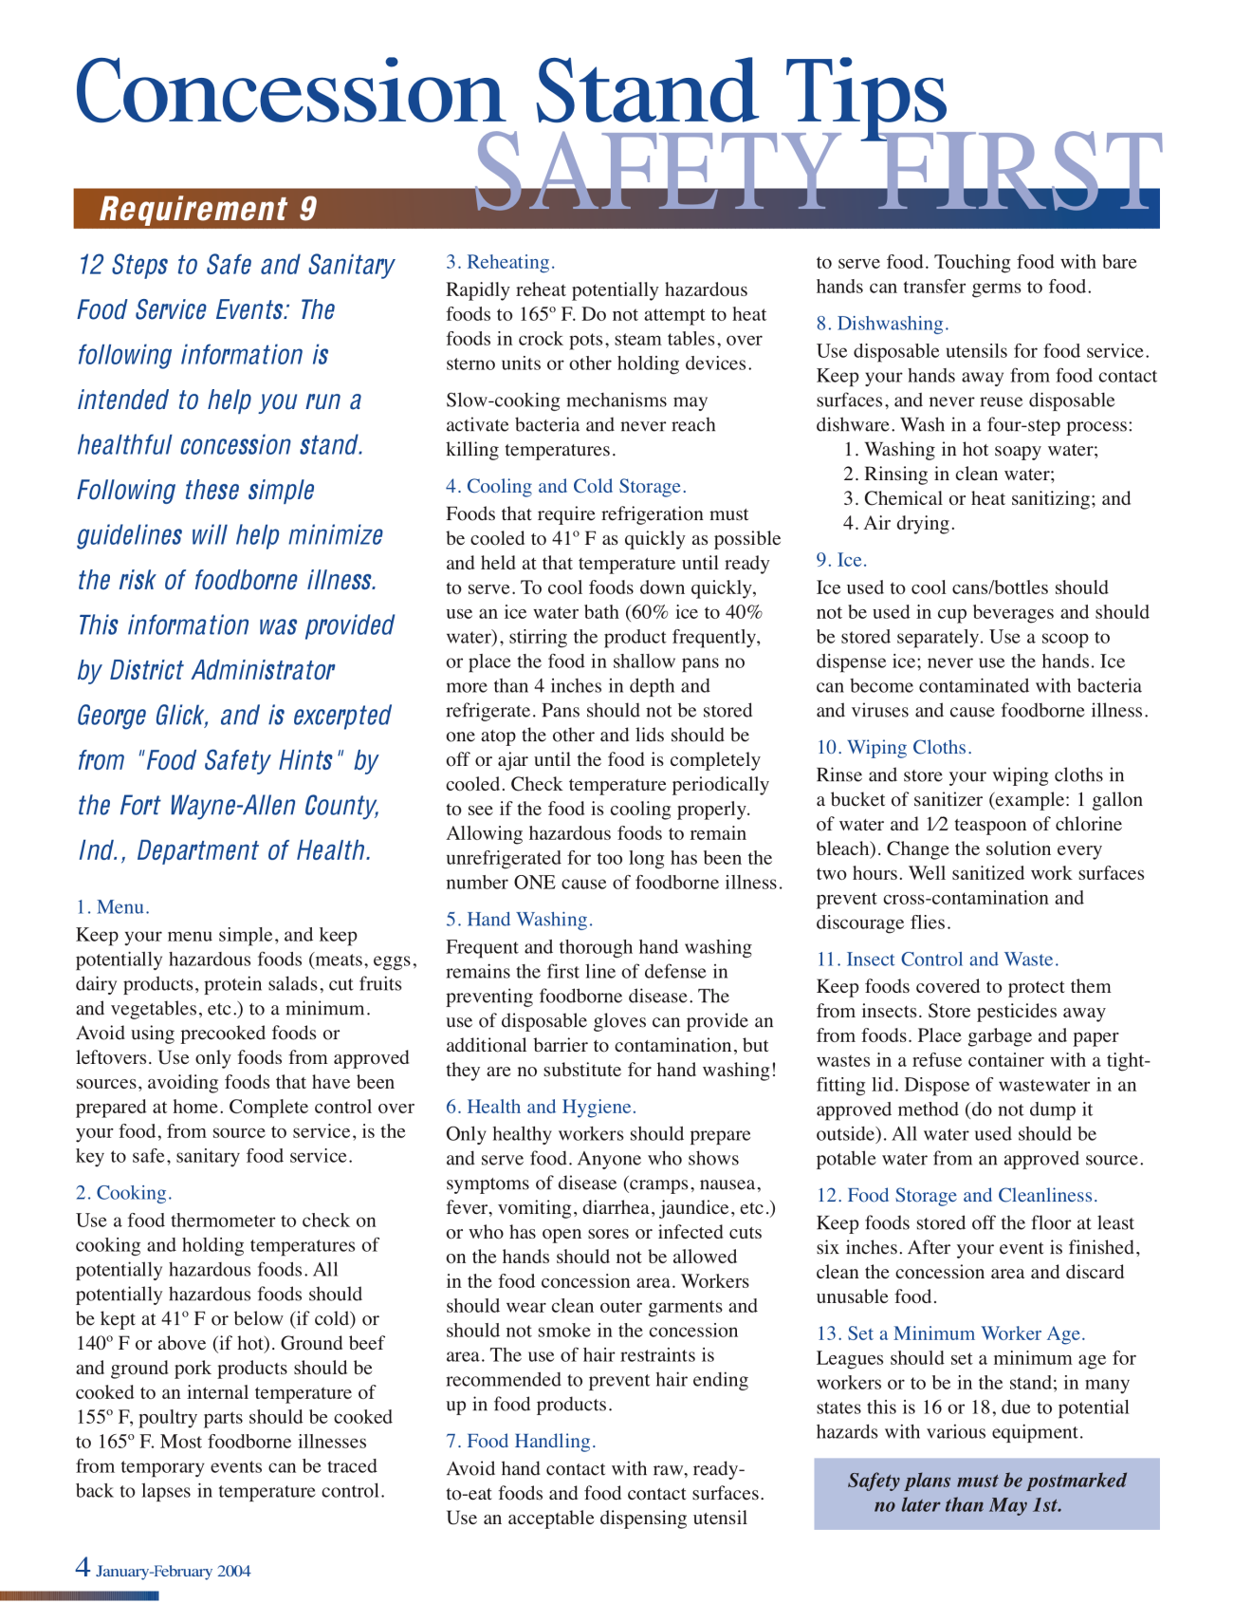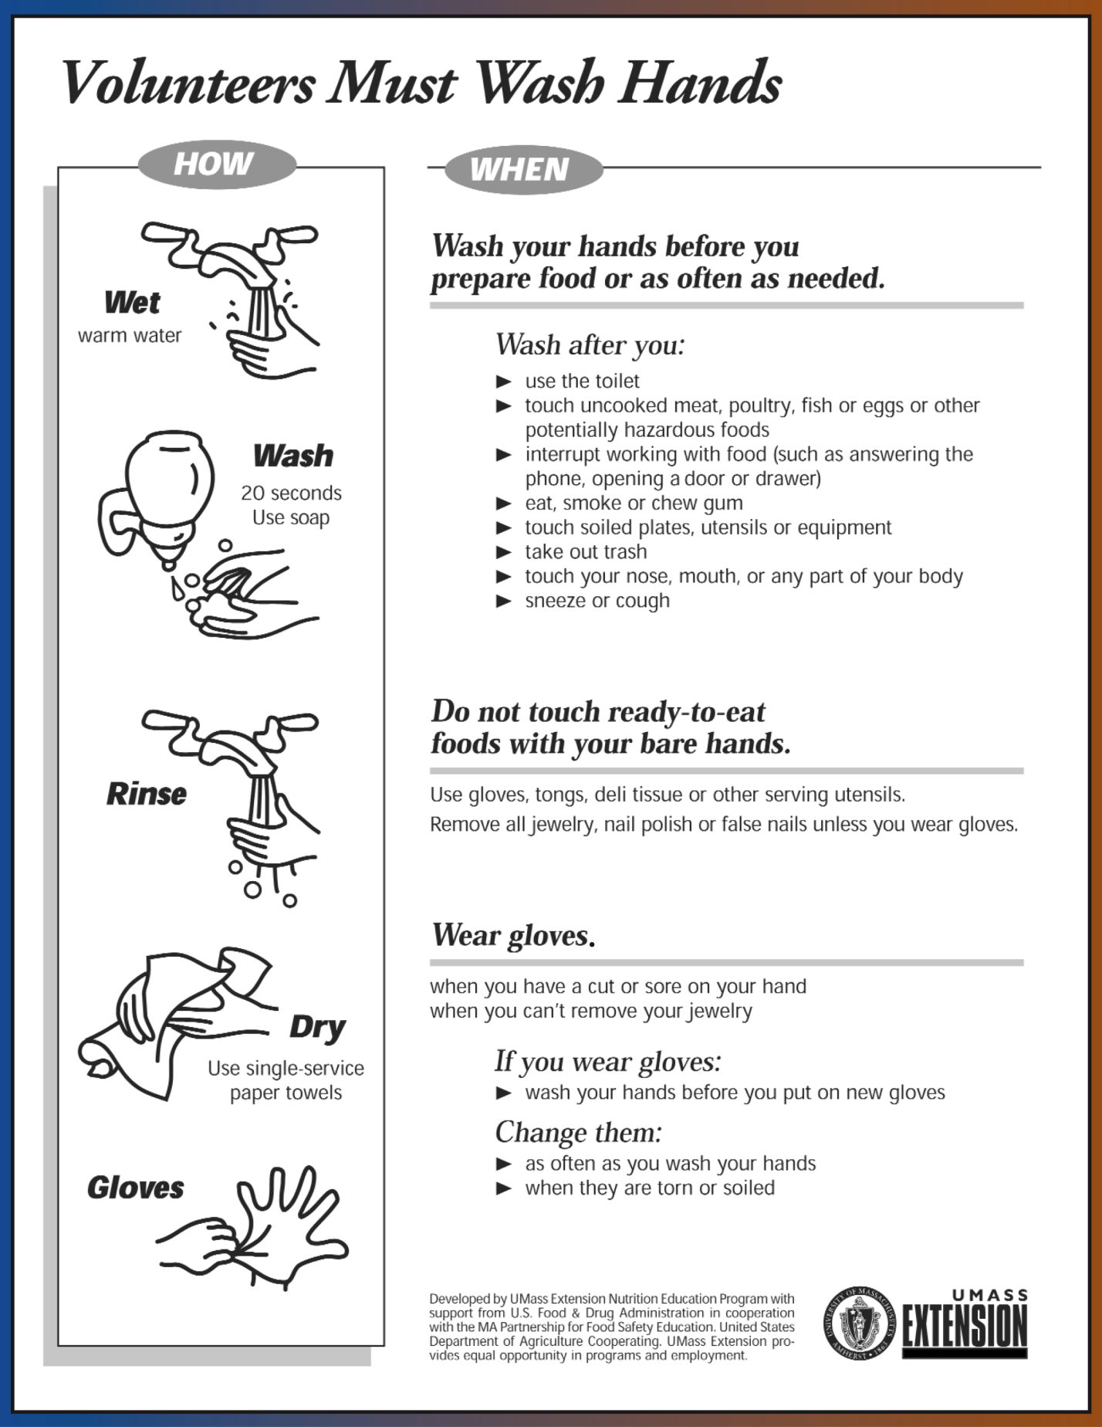
COMMUNICABLE DISEASE PROCEDURES

While risk of one athlete infecting another with HIV/AIDS during competition is close to non-existent, there is a remote risk that other blood born infectious diseases can be transmitted. For example, Hepatitis B can be present in blood as well as in other body fluids.

Procedures for reducing the potential for transmission of these infectious agents should include, but not be limited to, the following:

- The bleeding must be stopped, the open wound covered, and if there is an excessive amount of blood on the uniform it must be changed before the athlete may participate.

- Routine use of gloves or other precautions to prevent skin and mucous-membrane exposure when contact with blood or other body fluids is anticipated.

- Immediately wash hands and other skin surfaces if contaminated (in contact) with blood or other body fluids. Wash hands immediately after removing gloves.

- Clean all contaminated surfaces and equipment with an appropriate disinfectant before competition resumes.

- Practice proper disposal procedures to prevent injuries caused by needles, scalpels, and other sharp instruments or devices.

- Although saliva has not been implicated in HIV transmission, to minimize the need for emergency mouth-to-mouth resuscitation, mouthpieces, resuscitation bags, or other ventilation devices should be available for use.

- Athletic trainers/coaches with bleeding or oozing skin conditions should refrain from all direct athletic care until the condition resolves.

- Contaminated towels should be properly disposed of/disinfected.

- Follow acceptable guidelines in the immediate control of bleeding and when handling bloody dressings, mouth guards, and other articles containing body fluids.

Additional information is available from your state high school association and from the National Federation TARGET program.

YOUTH SPORTS PARENT CODE OF CONDUCT
We, the Broad Ripple Haverford Little League, have implemented the following Sport Parent Code of Conduct for the important message it holds about the proper role of parents in supporting their child in sports.

Parents should read, understand and sign this form prior to their children participating in our league. Any parent guilty of improper conduct at any game or practice will be asked to leave the sports facility and be suspended from the following game. Repeat violations may cause a multiple game suspension, or the season forfeiture of the privilege of attending all games.

Preamble
The essential elements of character-building and ethics in sports are embodied in the concept of sportsmanship and six core principles:

• Trustworthiness,
• Respect,
• Responsibility,
• Fairness,
• Caring, and
• Good Citizenship.

The highest potential of sports is achieved when competition reflects these “six pillars of character.”

I hereby agree that:

- I will not force my child to participate in sports.

- I will remember that children participate to have fun and that the game is for youth, not adults.

- I will inform the coach of any physical disability or ailment that may affect the safety of my child or the safety of others.

- I will learn the rules of the game and the policies of the league.

- I (and my guests) will be a positive role model for my child and encourage sportsmanship by showing respect and courtesy, and by demonstrating positive support for all players, coaches, officials and spectators at every game, practice or other sporting event.

- I (and my guests) will not engage in any kind of unsportsmanlike conduct with any official, coach, player, or parent such as booing and taunting; refusing to shake hands; or using profane language or gestures.

- I will not encourage any behaviors or practices that would endanger the health and well-being of the athletes.

- I will teach my child to play by the rules and to resolve conflicts without resorting to hostility or violence.

- I will demand that my child treat other players, coaches, officials and spectators with respect regardless of race, creed, color, sex or ability.

- I will teach my child that doing one’s best is more important than winning, so that my child will never feel defeated by the outcome of a game or his/her performance.

- I will praise my child for competing fairly and trying hard, and make my child feel like a winner every time.

- I will never ridicule or yell at my child or other participants for making a mistake or losing a competition.

- I will emphasize skill development and practices and how they benefit my child over winning. I will also de-emphasize games and competition in the lower age groups.

- I will promote the emotional and physical wellbeing of the athletes ahead of any personal desire I may have for my child to win.

- I will respect the officials and their authority during games and will never question, discuss, or confront coaches at the game field, and will take time to speak with coaches at an agreed upon time and place.

- I will demand a sports environment for my child that is free from drugs, tobacco, and alcohol and I will refrain from their use at all sports events.

- I will refrain from coaching my child or other players during games and practices, unless I am one of the official coaches of the team.

______________________________________
Parent/Guardian Signature


VOLUNTEER CODE OF CONDUCT

The Broad Ripple Haverford Little League Board of Directors has mandated the following Code of Conduct. All coaches and managers will read this Code of Conduct and sign in the space provided below, acknowledging that he or she understands and agrees to comply with the Code of Conduct. Tear the signature sheet on the dotted line and return it to Thomas Mariani, President of the Broad Ripple Haverford Little League.

BROAD RIPPLE LITTLE LEAGUE CODE OF CONDUCT

- No board member, manager, coach, player or spectator shall, at any time, lay a hand upon, push, shove, strike, or threaten to strike an official.

- Be guilty of heaping personal verbal or physical abuse upon any official for any real or imaginary belief of a wrong decision or judgment.

- Be guilty of an objectionable demonstration of dissent at an official’s decision by throwing of gloves, helmets, bats, balls, or any other forceful unsportsmanlike conduct.

- Be guilty of using unnecessarily rough tactics in the play of a game against the body of an opposing player.

- Be guilty of a physical attack upon any board member, official, manager, coach, player or spectator.

- Be guilty of the use of profane, obscene or vulgar language in any manner at any time.

- Appear on the field of play, stands, or anywhere on the Little League complex while in an intoxicated state. Intoxicated will be defined as an odor or behavior issue.

- Be guilty of gambling upon any play or outcome of any game with anyone at any time.

- Smoke while on the grounds of the Indianapolis Public School Corporation. BRHLL leases land owned by IPS and will adhere to their smoke-free policy.

- Be guilty of publicly discussing with spectators in a derogatory or abusive manner any play, decision or a personal opinion on any players during any game.

- As a manager or coach, be guilty of excessive mingling with or fraternizing with spectators during the course of the game.

- Speak disrespectfully to any manager, coach, official or representative of the league.

- Be guilty of tampering or manipulating any league rosters, schedules, draft positions, or selections, official score books, pitch counts, rankings, financial records or procedures.

- Challenge an umpire’s authority. The umpires shall have the authority and discretion during the game to penalize the offender according to the infraction up to an including expulsion from the game.

The Board of Directors will review all infractions of the Code of Conduct. Depending on the seriousness or frequency, the Board may assess additional disciplinary action up to and including expulsion from the league.

I have read the Broad Ripple Haverford Little League Code of Conduct and promise to adhere to its rules and regulations.

_____________________________ _______________________________
Print Name of Manager/Coach Team Name and Division

2022 BRHLL FACILITY SURVEY

[SEE FOLLOWING PAGES]

2022 BRHLL Coronavirus Mitigation Plan

BRHLL will follow the direction of the Marion County Health Department regarding Coronavirus mitigation planning. As there are currently no requirements to contract trace or report coronavirus cases to the Department of Health, we will simply ask players and managers to stay home if they are experiencing Covid-19 symptoms. Face masks are not required. Nevertheless, as most people are aware, these guidelines are subject to change. We will “pivot” as needed, and follow the advice of the MCHD.

